Shaquille Regis

2000686590

CPE 301-1001

Design Assignment 1A

The purpose of this assignment is to multiply a 16-bit number by an 8-bit number without the use of the MUL instruction. The solution provided below uses an iterative loop of addition with carry to achieve the same result. The result of the multiplication is a 24-bit number stored across R18:R19:R20. For this example, we will do following:

10000 = 0x2710

100 = 0x64

10000 \* 100 = 1000000 or 0x2710 \* 0x64 = 0x0F4240

Code:

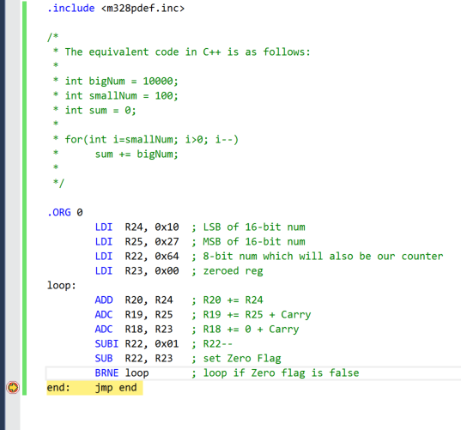

Initially, R22 contains the 8-bit number 0x64, R25:24 contains the 16-bit number 0x2710.

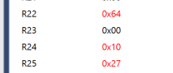

Following the loop, the 24-bit result 0x0F4240 is shown across R18:R19:R20.

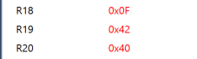

This program takes 702 cycles to complete. With a clock speed of 16MHz, the program should have an execution time of 43.88us.

